**Deep Learning: Charity Funding Predictor**

**Overview**

The purpose of this analysis was to create an algorithm that would predict whether or not applicants for funding will be successful. By using machine learning and neural networks, I used the features provided in the dataset to create a binary classifier that is capable of this prediction.

**Results**

Based on the instructions, EIN and NAME were dropped from the model. The remaining columns were used as features for the model analysis. The data was then split into training and test sets for evaluation.

There were three layers of the neural network in the first attempt. The number of features were identified by the number of hidden nodes.

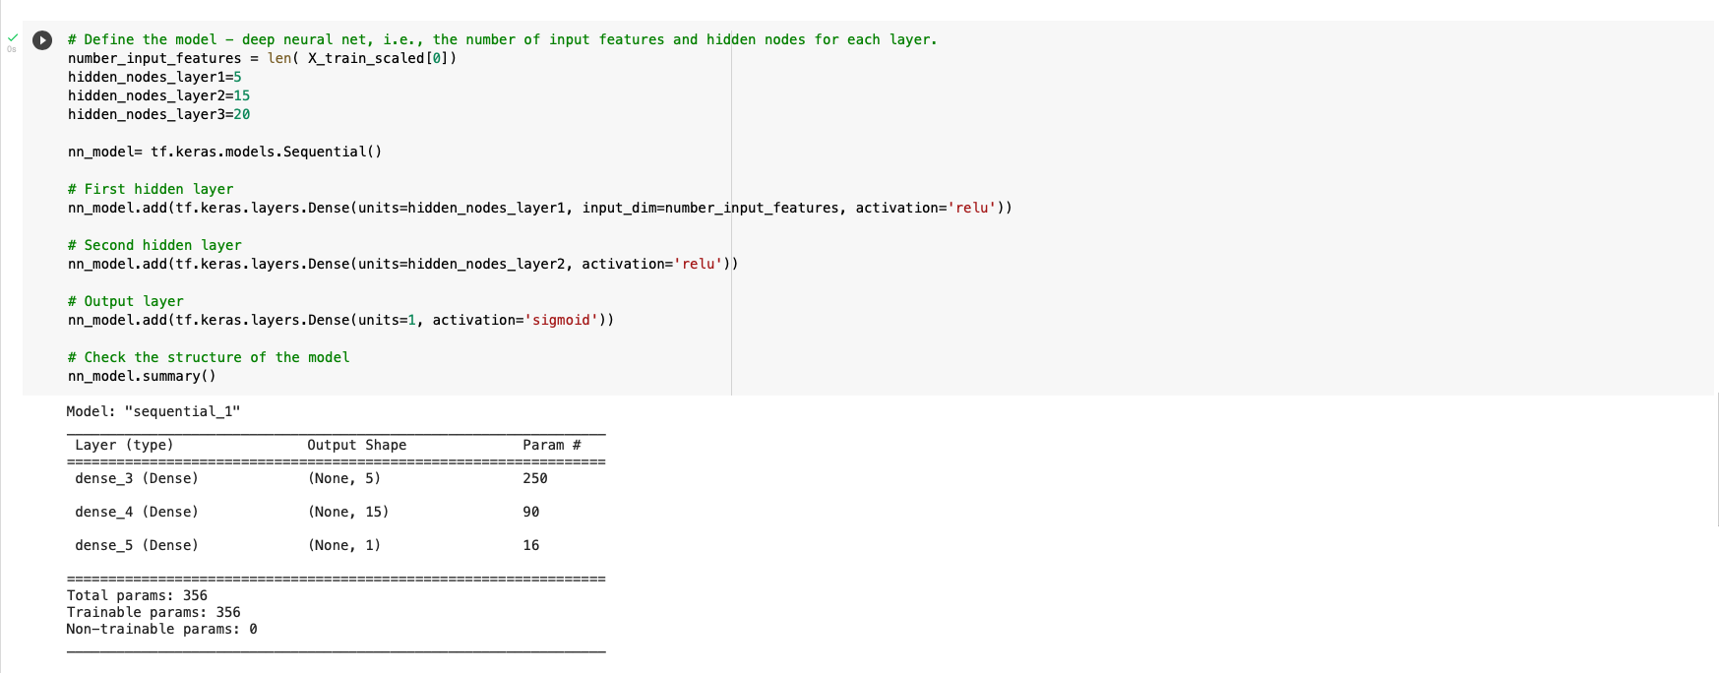

This training model generated 356 parameters and an accuracy of 72.96%.



In a second attempt to increase the accuracy, I kept the EIN and dropped only the NAME column.



This training model generated 1,176 parameters with an accuracy of 72.88% which is slightly worse than the previous model.

As final attempt, I removed NAME, EIN, and ORGANIZATION from the dataset, in order to reduce the number of features. I also increased the number of hidden layers. This training model generated 631 parameters with an accuracy of 72.71% which has the lowest accuracy of all the models.

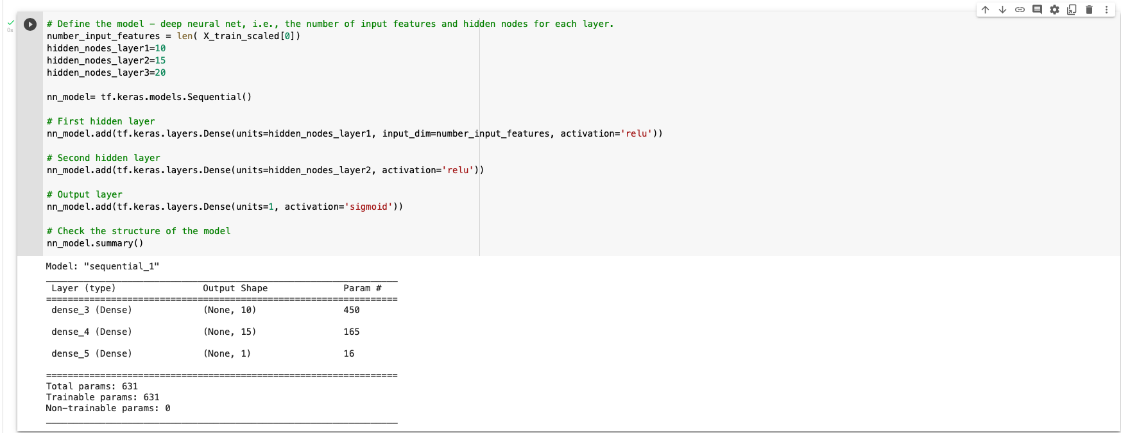

Unfortunately, I was unable to achieve the target model performance. However, there are many more modifications that can be attempted to increase the accuracy.